ISAM 5931 Assignment 2

In this assignment, students practice how to use pandas library.

Q1. Create a pandas Series named “grades” as the following. Display the Series.

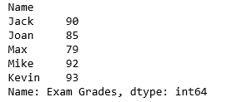

Q2. Display the highest, lowest and average grade in the grades of Q1.

Q3. Display the names and grades where the grades are greater than or equal to the average. Please refer the following as the output.

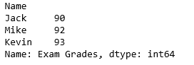

Q4. Display Joan’s and Jack’s grades using one statement. Please refer the following as the output.

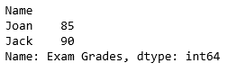

Q5. Change Joan’s grade to be 95 and display all grades. Please refer the following as the output.

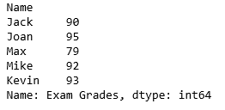

Q6. Create a DataFrame similar to the vehicles sales 2D-Array used in Assignment 1. Please refer the following for the output.

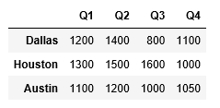

Q7. Display the sales of Q3 and display the sales of Houston, respectively (in two statements).

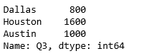

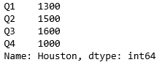

Q8. Add a Total column to the DataFrame. Add a name of “Quarter” to the columns and add a name of “City” to the index.

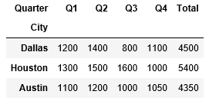

Q9. Display the values, index and columns of sales.

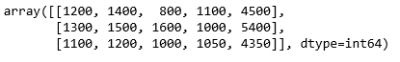





Q10. Reindex the DataFrame’rows to the order: Austin, Dallas, Houston. This will create another copy of sales. The order of index in the original object does not change.

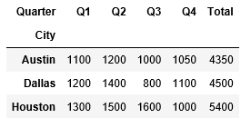

Q11. Display the sales of Q2 and Q3.

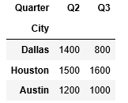

Q12. Display the rows where Q3 sales is greater than or equal to 1000.

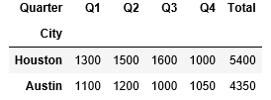

Q13. Sort the DataFrame’s values based on “Total”, from large to small. The following output should appear.

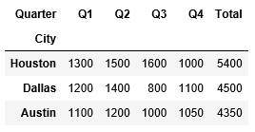

Q14. Add another column named “Average” to sales.

